2)
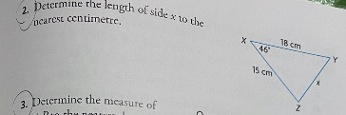
Given
By applying cosine rule,
X²=15²+18²-2(15)(18)cos46
=(225+324) -540 cos (46)
=549-375.11
=13.186 cm
3)
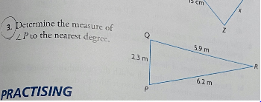
Applying cosine rule,
5.9²= 6.2²+2.3²-2(6.29)(2.3)cosp
34.81=(38.44+5.29)-28.52 cosp
34.81=43.73-28.52cosp
Cosp=(43.73-34.81)/28.52
Angle p=71.774

4)
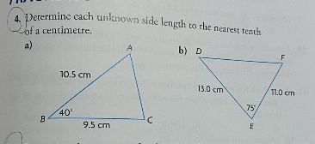
a)
By applying cosine rule,
X²= 9.5² +10.5²- 2(9.5)(10.5)cos40
= (90.25+110.25)-199.5cos40
= 200.5-199.5 cos 40
X=6.904 cm
b)
By applying cosine rule,
X² = 13² +11²-2(13)(11)cos75
=(169+121)-286cos75
=290-286 cos75
X=14.696 cm

5)
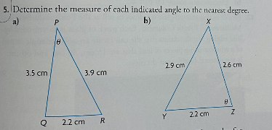
a) By applying cosine rule,
2.2² =3.9² +3.5²- 2(3.9)(3.5)cosθ
4.84=(15.21 +12.25)-27.3cosθ
4.84=27.46-27.3 cosθ
θ=34.047
b) By applying cosine rule,
2.9²=2.2²+2.6²-2(2.2)(2.6)cosθ
8.41=(4.84+6.76)-11.4cosθ
8.41= 11.6-11.4cosθ
θ =73.75
6)
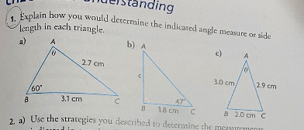

a) By using sine rule,
2.7/sin 60 =3.1/sinθ
Sinθ = 3.1/2.7(sin60)
Sinθ =1.1489(sin 60)
Sinθ =0.994
θ =83.893
b)
θ +47+90=180
θ=43
By sine rule,
1.8/sin 43 =c/sin 47
C= 1.93cm
c)
By applying cosine rule,
2² ⁼ 3² +2.9²- 2(3)(2.9)cosθ
4=(9+8.41)-17.4cosθ
4=17.41-17.4 cosθ
θ =39.584

7)
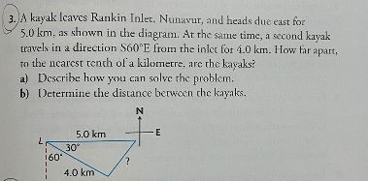
a) We can solve the problem by applying cosine rule in the diagram.
b) Let x be the distance between two kayaks,
x²= 5² +4²- 2(5)(4)cos30
=(25 +16)-40cos30
=41-40cos30
x =2.521km

8)
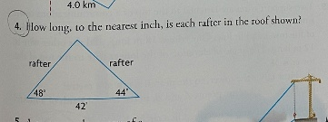
Sum of angles in a triangle = 180
44+48+$θ$=180
θ=88

rafter1= x₁
rafter2= x₂
By applying sine rule,
42/sin88=x₁/sin44
x₁=29.19 inch
42/sin88 =x₂/sin48
X₂= 31.23 inch
9)
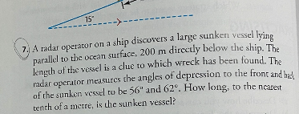
tan 62 = 200/a
a = 200/tan62
a = 106.3
tan 56 = 200/b
b = 200/tan56
b = 134.9
a + b = 241.2m

10)
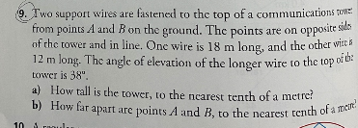
a)
θ+38+90=180
θ=52
by using sine rule,
18/sin 90=h/sin38
h=11.08m

b)tan38 = 12/a
a = 12/tan38
a =15.3
Tan52 = 18/b
b = 18/tan52
b = 14.0
a + b = 29.3m

